Programming language: R

Data: *cities.csv*

**INTRODUCTION**

The following has the exploratory data analysis and visualization of 500 top cities of India performed using R. Data source: Kaggle. Data wrangling and data analysis performed using dplyr, plyr; data visualization using ggplot.

**READ DATA**

cities<- read.csv(“C:/Career/Study/Data/Kaggle data/500 Indian Cities/cities_r2”)

view(cities)

library(dplyr)

library(plyr)

library(ggplot2)

library(gridextra)

library(xlsx)

library(DT)

**EXPLORATORY DATA ANALYSIS**

by_state <- cities %>% group_by(state_name) %>% summarise(Total = n(), Population = sum(population_total), Male_Population = sum(population_male), Female_Population = sum(population_female), Male_Percent = Male_Population/Population * 100, Female_Percent = Female_Population/Population * 100, Graduates = sum(total_graduates), Male_Grads = sum(male_graduates), Female_Grads = sum(female_graduates), Grads_percent = Graduates/Population * 100, Male_Grads_Percent = Male_Grads/Male_Population * 100, Female_Grads_Percent = Female_Grads/Female_Population * 100) %>% arrange(desc(Total))

**Cities based on States**

ggplot(by_state, aes(state,Total)) + geom_bar(stat = "identity", fill= "blue") + scale_y_continuous(breaks= seq(0,45,5)) + ggtitle("Cities on States") + xlab("State") + ylab("Cities")

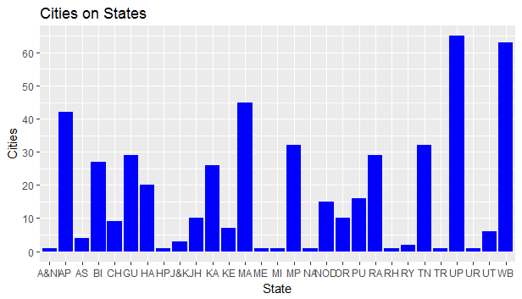

**Population based on States:**

viz1<- ggplot(by_state, aes(state, population_in_mil)) + geom_bar(stat = "identity", fill= "blue") + scale_y_continuous(breaks= seq(0,45,5)) + ggtitle("Population based on States") + xlab("State") + ylab("Population (in millions)")

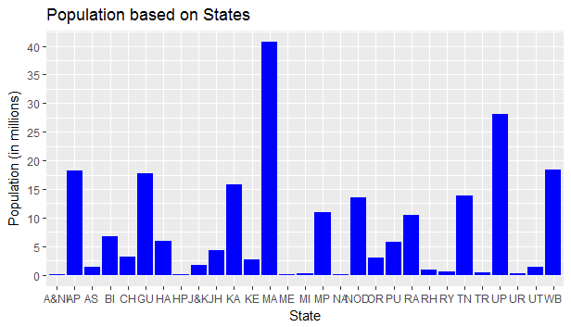

**Male Population based on states:**

viz3<- ggplot(by_state, aes(state, Male_Population_in_mil)) + geom_bar(stat = "identity", fill= "blue") + scale_y_continuous(breaks= seq(0,22,4)) + ggtitle("Male Population based on States") + xlab("State") + ylab("Male Population (in Mil)")

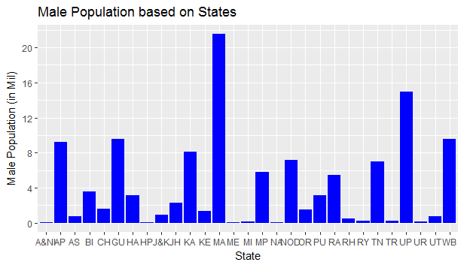

**Female Population based on states:**

viz4<- ggplot(by_state, aes(state, Female_Population_in_mil)) + geom_bar(stat = "identity", fill= "blue") + scale_y_continuous(breaks= seq(0,20,4)) + ggtitle("Female Population based on States") + xlab("State") + ylab("Female Population (in Mil)")

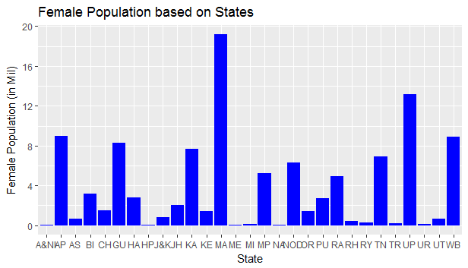

**Male vs Female Population**

grid.arrange(viz3, viz4)

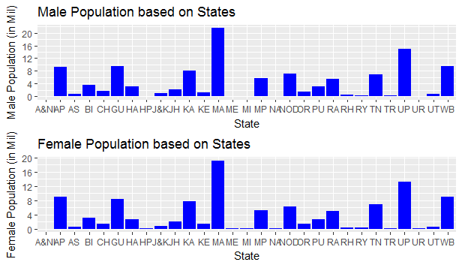

**Graduates based on States**

ggplot(by_state, aes(state, Graduates)) + geom_bar(stat= "identity", fill= "blue") + scale_y_continuous(breaks= seq(0,5494343,1000000))+ xlab("State") + ylab("Graduates") + ggtitle(" Graduates based on State")

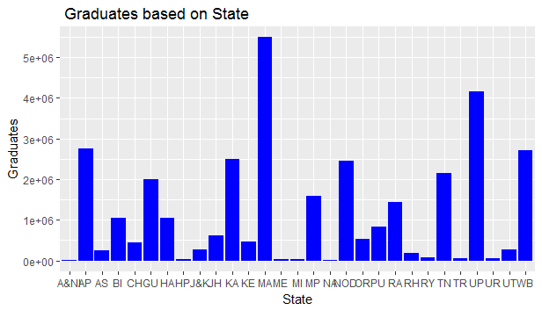

**Male Graduates based on States**

viz5<- ggplot(by_state, aes(state, Male_Grads)) + geom_bar(stat= "identity", fill= "blue") + scale_y_continuous(breaks= seq(0,5494343,1000000))+ xlab("State") + ylab("Male Graduates") + ggtitle(" Male Graduates based on State")

viz6<- ggplot(by_state, aes(state, Female_Grads)) + geom_bar(stat= "identity", fill= "blue") + scale_y_continuous(breaks= seq(0,5494343,1000000))+ xlab("State") + ylab("Female Graduates") + ggtitle(" Female Graduates based on State")

grid.arrange(viz5,viz6)

